# Create a Spring Web Project using Maven –

Project Structure -

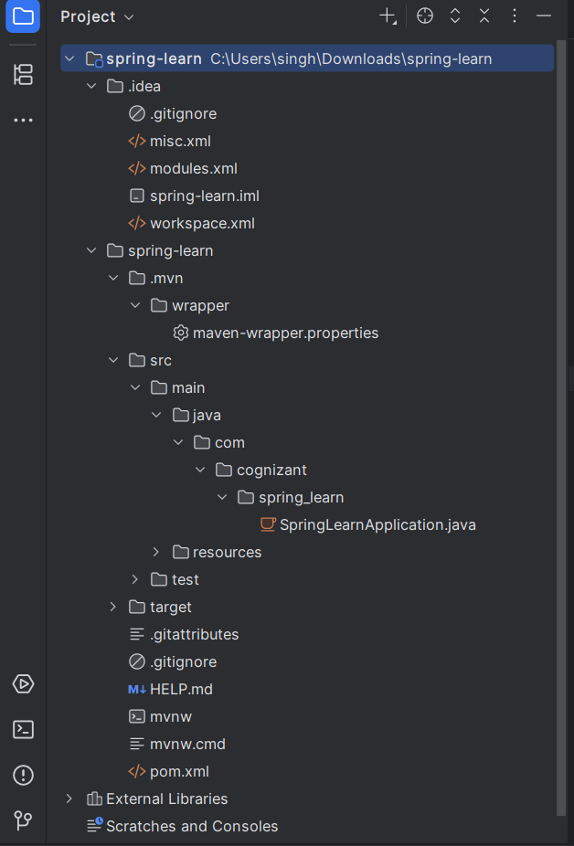

Spring Learn Application Class –

